**GREEN CARE ASSISTANT BOT**

**A PROJECT REPORT**

***Submitted by***

**BLESSY ABIDHA B. S. (2116220701047)**

***in partial fulfilment for the course***

**OAI1903 - INTRODUCTION TO ROBOTIC PROCESS AUTOMATION**

***for the degree of***

**BACHELOR OF ENGINEERING**

**in**

**COMPUTER SCIENCE AND ENGINEERING**

**RAJALAKSHMI ENGINEERING COLLEGE**

**RAJALAKSHMI NAGAR**

**THANDALAM**

**CHENNAI – 602 105**

**NOVEMBER 2024**

**RAJALAKSHMI ENGINEERING COLLEGE**

**CHENNAI - 602105**

**BONAFIDE CERTIFICATE**

Certified that this project report **“GREEN CARE ASSISTANT BOT”** is the Bonafide work of **“BLESSY ABIDHA B. S. (2116220701047)”** who carried out the project work for the subject OAI1903-Introduction to Robotic Process Automation under my supervision.

|  |
| --- |
| Mrs. J. Jinu Sophia  **SUPERVISOR**  Assistant Professor (SG)  Department of  Computer Science and Engineering  Rajalakshmi Engineering College  Rajalakshmi Nagar  Thandalam  Chennai - 602105 |
|  |

Submitted to Project and Viva Voce Examination for the subject OAI1903-Introduction to Robotic Process Automation held on __________.

**ACKNOWLEDGEMENT**

Initially we thank the Almighty for being with us through every walk of our life and showering his blessings through the endeavour to put forth this report. Our sincere thanks to our Chairman **Thiru. S. Meganathan, B.E., F.I.E.,** our Vice Chairman **Mr. M. Abhay Shankar, B.E., M.S.,** and our respected Chairperson **Dr. (Mrs.) Thangam Meganathan, M.A., M.Phil., Ph.D.,** for providing us with the requisite infrastructure and sincere endeavouring in educating us in their premier institution.

Our sincere thanks to **Dr. S. N. Murugesan, M.E., Ph.D.,** our beloved Principal for his kind support and facilities provided to complete our work in time. We express our sincere thanks to **Dr. P. Kumar, M.E., Ph.D.,** Professor and Head of the Department of Computer Science and Engineering for his guidance and encouragement throughout the project work. We convey our sincere and deepest gratitude to our internal guides, **Mrs. J. Jinu Sophia, M.E., (Ph.D.)** Assistant Professor (SG) Department of Computer Science and Engineering for their valuable guidance throughout the course of the project. We are very glad to thank our Project Coordinator Professor, **Dr. N. Durai Murugan, M.E., Ph.D.,** Associate Professor and Mr. **B. Bhuvaneswaran, M.E.,** Assistant Professor (SG), Department of Computer Science and Engineering for their useful tips during our review to build our project.

**BLESSY ABIDHA B. S. (2116220701047).**

**ABSTRACT:**

The Green Care Assistant Bot is a cutting-edge automation tool designed to revolutionize plant maintenance by providing personalized care schedules. Developed using UiPath, the bot seamlessly integrates plant-specific care data, user inputs such as the last care dates, and real-time weather information retrieved via an API to determine optimal schedules for watering, fertilizing, and pruning. With support for 15 plant species, the bot leverages Excel for efficient data storage and retrieval, automates date calculations, and customizes care recommendations based on temperature and humidity. By simplifying complex care routines and ensuring precise timing, the Plant Care Bot enhances plant health and provides an effortless solution for plant lovers, professionals, and hobbyists alike. It minimizes manual effort, adapts to environmental changes, and fosters optimal plant growth with timely, actionable insights.

**TABLE OF CONTENTS**

**CHAPTER NO. TITLE PAGE NO.**

**ABSTRACT 4**

**LIST OF TABLES 5**

**LIST OF FIGURES 6**

**LIST OF ABBREVIATIONS 7**

**1. INTRODUCTION 8**

1.1 GENERAL 8

1.2 OBJECTIVE 8

1.3 EXISTING SYSTEM 9

1.4 PROPOSED SYSTEM 9

**2. LITERATURE REVIEW 10**

2.1 GENERAL 10

**3. SYSTEM DESIGN 12**

3.1 GENERAL 12

3.1.1 SYSTEM FLOW DIAGRAM 12

3.1.2 ARCHITECTURE DIAGRAM 13

3.1.3 SEQUENCE DIAGRAM 14

**4. PROJECT DESCRIPTION 16**

4.1 METHODOLOGY 16

4.1.1 MODULES 17

**5. OUTPUT SCREENSHOTS 19**

**6. CONCLUSIONS 22**

**APPENDICES 23**

**REFERENCES 26**

**LIST OF FIGURES**

|  |  |  |
| --- | --- | --- |
| **Figure No.** | **Figure Name** | **Page No.** |
| 3.1.1 | System Flow Diagram | 12 |
| 3.1.2 | Architecture Diagram | 13 |
| 3.1.3 | Sequence Diagram | 15 |
| 5.1 | Plant Type Input | 19 |
| 5.2 | Plant Location Input | 19 |
| 5.3 | Last Watered Date | 20 |
| 5.4 | Last Fertilized Date | 20 |
| 5.5 | Plant Data in Excel Sheet | 21 |
| 5.6 | Output Display of Calculated Dates | 21 |

**LIST OF ABBREVIATIONS:**

|  |  |
| --- | --- |
| **Abbreviation** | **Full Form** |
| **ERD** | **Entity Relationship Diagram** |
| **DFD** | **Data Flow Diagram** |
| **HR** | **Human Resources** |
| **API** | **Application Programming Interface** |
| **RE** | **Robotic Enterprise** |
| **RPA** | **Robotics Process Automation** |

**CHAPTER-1**

**INTRODUCTION**

Maintaining plant health requires consistent care, which can be challenging due to varying plant needs and environmental factors. The Plant Care Bot simplifies this process by automating care schedules for watering, fertilizing, and pruning. Developed using UiPath, the bot integrates user inputs, plant-specific data, and real-time weather information to provide personalized recommendations. This innovative solution ensures healthier plants with minimal effort, making plant care easier and more efficient.

**1. 1 GENERAL**

Plant care is an essential aspect of maintaining a healthy and sustainable environment, whether for home gardens, office spaces, or large-scale plantations. Each plant species has unique requirements for watering, fertilizing, and pruning, influenced by environmental factors such as temperature and humidity. Managing these schedules manually can be time-consuming and prone to errors, especially for individuals with limited knowledge or busy routines.

**1.2 OBJECTIVE**

The objective of this project is to develop an automated Plant Care Bot using UiPath that simplifies plant maintenance by providing personalized care schedules. By integrating user inputs, plant-specific requirements, and real-time weather data, the bot calculates optimal watering, fertilizing, and pruning times. This ensures efficient care management, enhances plant health, and reduces the effort required for routine plant maintenance.

**1.3 EXISTINGSYSTEM**  
 In the current scenario, plant care is typically managed manually by individuals, relying on personal knowledge, generic guidelines, or physical reminders. This approach often leads to inconsistencies, such as overwatering or neglect, due to a lack of precise scheduling tailored to each plant's specific needs. Additionally, environmental factors like temperature and humidity, which significantly impact plant health, are rarely considered in traditional care routines. While some mobile apps and gardening tools provide basic care recommendations, they often lack automation, integration with real-time weather data, and the ability to manage multiple plants efficiently, making plant care time-consuming and error-prone.

**1.4 PROPOSED SYSTEM**   
 The proposed system is an intelligent Green Care Assistant Bot developed using UiPath to automate and streamline plant maintenance tasks. It leverages user-provided inputs, plant-specific care data, and real-time weather information to calculate personalized schedules for watering, fertilizing, and pruning. The bot stores data for multiple plant species, automates care recommendations, and integrates with weather APIs to adapt to environmental changes. Using Excel for data management, the system ensures efficient tracking and updating of schedules. By reducing manual effort and incorporating real-time insights, the proposed system simplifies plant care, enhances plant health, and provides a user-friendly solution for effective maintenance.

**CHAPTER-2**

**LITERATURE­_REVIEW**

Technological advancements have highlighted the need for automating plant care to overcome challenges like inconsistent schedules and environmental changes. Research on IoT systems and mobile apps shows potential but often lacks affordability and adaptability. Studies on weather API integration and automation demonstrate improved care precision, setting the stage for the innovative ***Green Care Assistant Bot*** to address these gaps efficiently.

**2.1 GENERAL**  
 The integration of technology in plant care has been a growing field, with research focusing on automation and real-time adaptability to improve plant health. Studies indicate that improper watering, fertilizing, and pruning practices are the primary causes of plant stress and reduced growth. Manual tracking methods, though widely used, are prone to errors and fail to consider environmental factors like temperature, humidity, and seasonal changes that significantly influence plant requirements.

Authors in studies related to IoT have discussed systems that automate plant care using soil moisture sensors, temperature monitors, and other environmental factors. For example, a study on "IoT-based Smart Gardening Systems" by Kumar et al. (2020) highlights the role of sensors and automation in improving plant maintenance practices.

In agricultural technology, weather APIs have been used to predict optimal watering times and crop cycles. A paper titled *"Weather-Based Smart Irrigation Systems"* by Sharma et al. (2019) discusses how real-time weather data can optimize water usage and improve plant health.

Research on using automation tools for farming, such as robotic irrigation systems and automated scheduling, has been discussed by authors like Smith and Jones in their 2021 paper *"Automation in Precision Agriculture: Current Trends and Future Directions."* These studies often focus on large-scale agricultural applications but provide insights relevant to smaller-scale plant care automation.

Mobile apps and software for personal plant care have been evaluated in papers like *"Evaluating the Effectiveness of Digital Tools for Home Gardening"* by Nguyen et al. (2022). These tools often lack advanced automation, highlighting the need for systems like the Plant Care Bot.

**CHAPTER-3**

**SYSTEM DESIGN**

**3.1.1 SYSTEM FLOW DIAGRAM**

The **System Flow Diagram** outlines the overall flow of data and processes in the system. It demonstrates how user inputs, system processing, and outputs interact.

**Description**

1. **Input**: User data (plant name, location, last care dates) and an Excel sheet with plant-specific care details; real-time weather data via API.
2. **Process**: Read inputs, retrieve plant data, fetch weather conditions, and calculate personalized care schedules (watering, fertilizing, pruning).
3. 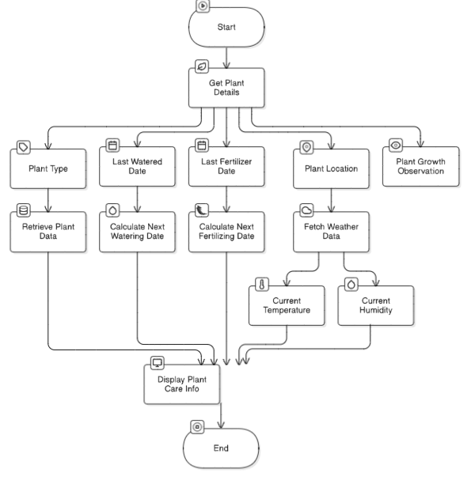**Output**: Display next care dates, weather-based recommendations, and logs for successful operations or errors.

**Fig3.1.1.SystemFlow Diagram**

**3.1.2 ARCHITECTURE DIAGRAM**

The **Architecture Diagram** provides a high-level view of the system's structure and its components.

**Components**:

1. **Frontend**: User interface to input plant details (e.g., UiPath Forms or input dialogs).
2. **Backend**: Core logic, including:
   * Excel processing to retrieve plant-specific data.
   * Weather API integration for real-time data.
   * Care schedule calculations (watering, fertilizing, pruning).
3. **Database/Storage**: Excel sheet to store plant data and user inputs.
4. 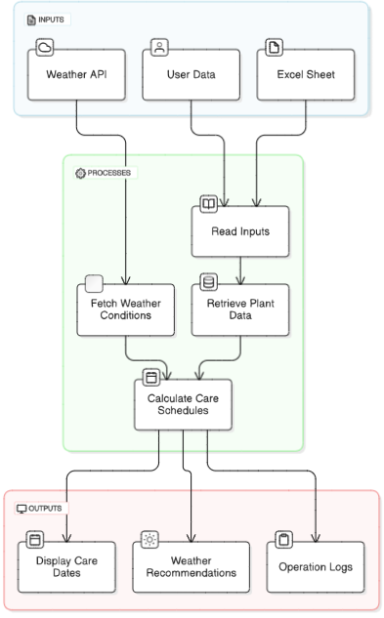**External Services**: Weather API for temperature and humidity data retrieval.

**Fig 3.1.2 Architecture Diagram**

**3.1.3 SEQUENCE DIAGRAM**

The Sequence Diagram shows the interaction between actors (users) and the components of the **“*Green Care Assistant Bot”*** in a sequential manner.

**Steps**:

* The user triggers the bot and provides plant details (e.g., name, location, last care dates).
* The bot reads the Excel sheet to retrieve plant-specific care data.
* The bot fetches real-time weather data from the Weather API.
* The bot calculates:

- Next watering and fertilizing dates.

- Pruning schedules based on plant type and weather conditions.

* The bot displays care recommendations to the user.
* Logs success or handles errors (e.g., invalid inputs or API failures).
* The bot notifies the user of the process completion.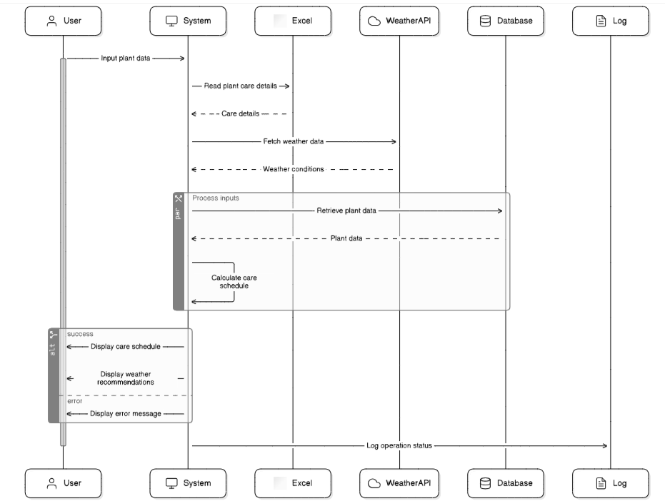

**Fig 3.1.3 Sequence Diagram**

**CHAPTER-4**

**PROJECT DESCRIPTION**

The **Green Care Assistant Bot** is designed to automate plant care scheduling by providing personalized recommendations for watering, fertilizing, and pruning based on user inputs, plant-specific data, and real-time weather conditions. Leveraging UiPath’s RPA capabilities, the bot simplifies plant maintenance, ensures optimal care, and reduces manual tracking efforts. This section outlines the methodologies used to develop the system and a breakdown of the core modules.

**4.1 METHODOLOGY**  
 The development of the **Green Care Assistant Bot** followed an agile methodology to ensure iterative progress and adaptability to project requirements. UiPath's RPA platform was utilized, focusing on structured execution, error handling, and scalability. Key steps in the methodology include:

1. **Requirements Gathering:** Initial requirements were gathered, including plant care specifications such as watering, fertilizing, and pruning frequencies, and the integration of real-time weather data for optimizing care schedules.
2. **System Design:** Detailed system designs, including flow diagrams, architecture diagrams, and sequence diagrams, were developed to ensure the bot could meet functional requirements and provide user-friendly interactions.
3. **Implementation:** The bot was implemented using UiPath with modules for Excel data retrieval, weather API integration, and schedule calculation. Advanced workflows were developed to automate care recommendations while ensuring error handling and efficient execution.
4. **Testing & Deployment:** The bot underwent rigorous testing to identify and resolve issues, such as incorrect data processing or API errors. After successful testing, the bot was deployed for real-world use, enabling users to manage plant care seamlessly.

**4.1.1 MODULES**:

1. **Excel Data Extraction Module:** This module reads plant-specific care data from an Excel sheet, including watering, fertilizing, and pruning frequencies. It filters the data based on the plant type provided by the user to retrieve relevant information for care schedule calculations.
2. **Weather Data Integration Module:** This module fetches real-time weather information (temperature and humidity) using a weather API. The weather data is used to optimize watering and fertilizing schedules based on environmental conditions.
3. **Schedule Calculation Module:** Using user-provided inputs (e.g., plant name, last watered date, location), this module calculates the next care dates for watering, fertilizing, and pruning. It combines data from the Excel sheet and weather API to generate accurate recommendations.
4. **Output and Recommendation Module:** This module displays the calculated care schedules to the user. It provides clear recommendations for watering, fertilizing, and pruning, along with any weather-based adjustments, ensuring easy-to-understand results.
5. **Logging and Error Management Module:** To ensure transparency and reliability, this module logs all actions, including successful data processing and weather data retrieval. It captures and handles errors, such as missing inputs or failed API responses, and provides relevant notifications to the user.
6. **User Interface Module:** This module serves as the interface for users to input plant details (e.g., name, location, last care dates) and view the care recommendations. It is designed for simplicity, allowing seamless interaction for users with varying technical skills.

**CHAPTER-5**

**OUTPUT SCREENSHOT**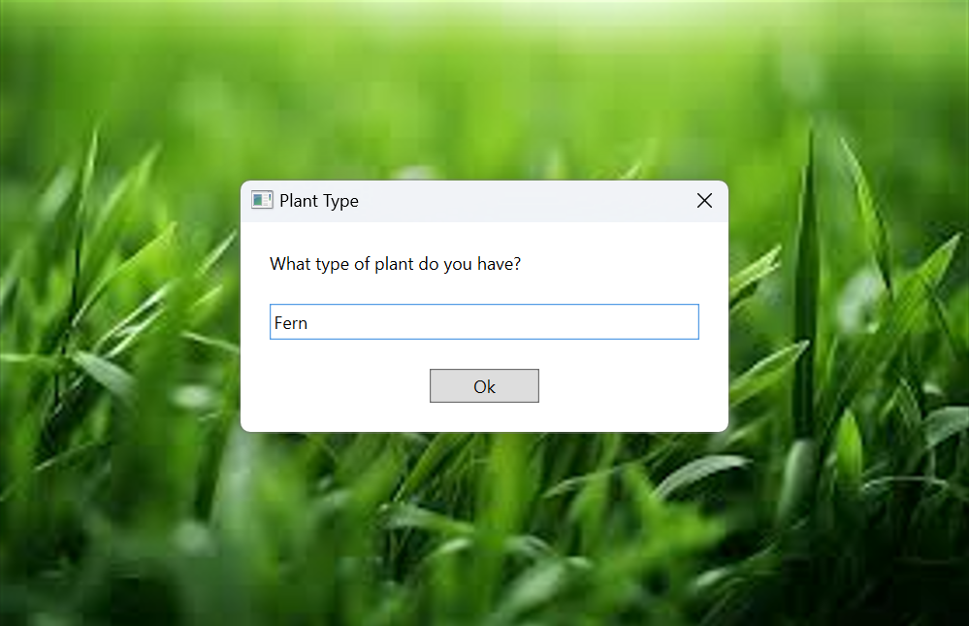

**Fig. 5.1. Plant Type Input**

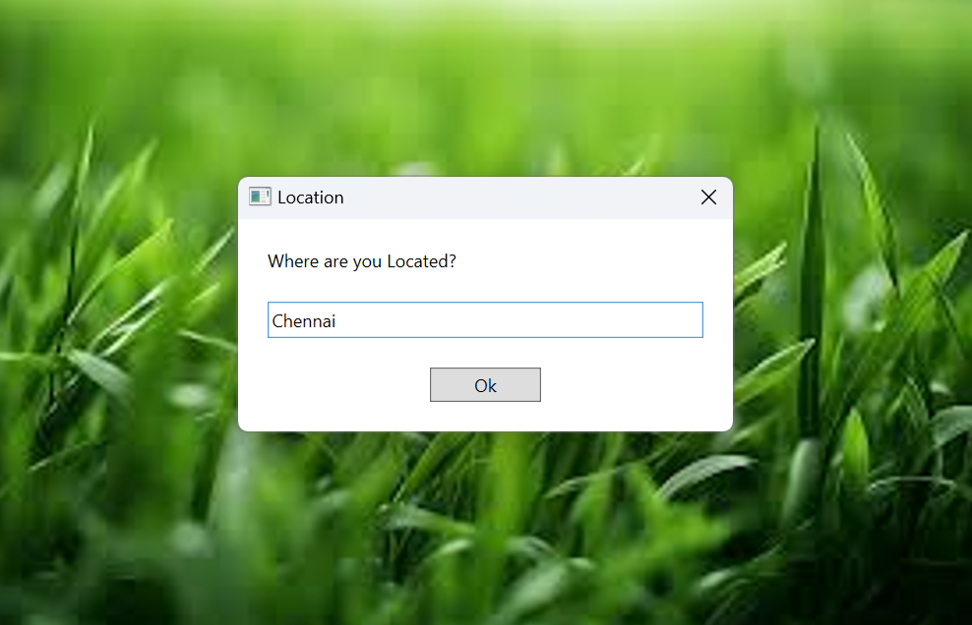Displays the plant types inputted into the system, showing various plant species and their corresponding details

**Fig 5.2 Plant Location Input**

The above Figure Displays the plant location, which is used to fetch localized weather data affecting plant care.

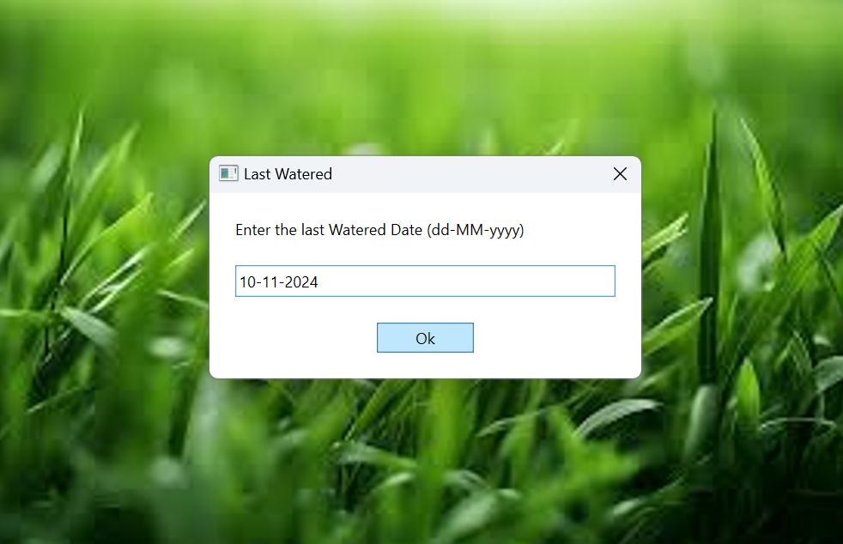

**Fig 5.3 Last Watered Date**

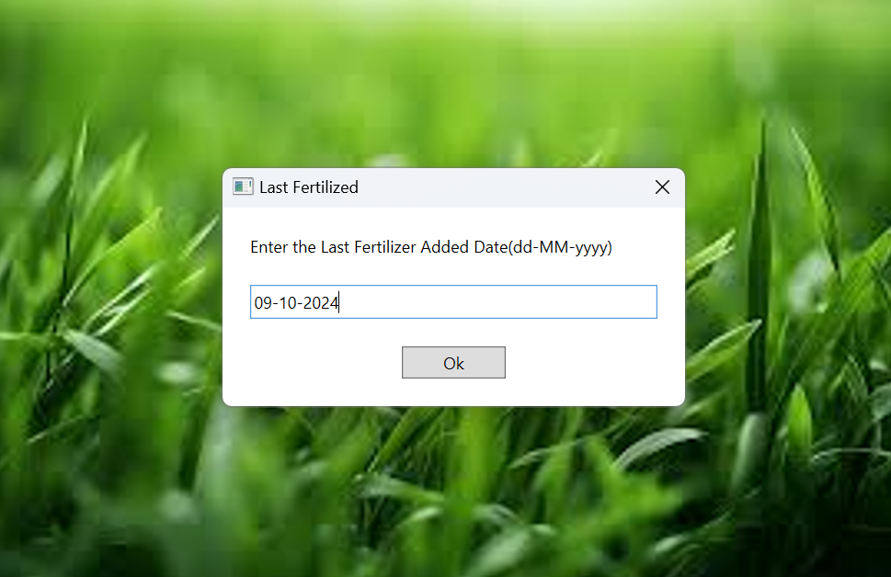The above Figure Shows the input data for the last watered date, used to calculate the next watering schedule for each plant.

**Fig 5.4 Last Fertilizer added date**

Displays the input data for the last fertilized date, which helps the bot calculate the next fertilizing date.

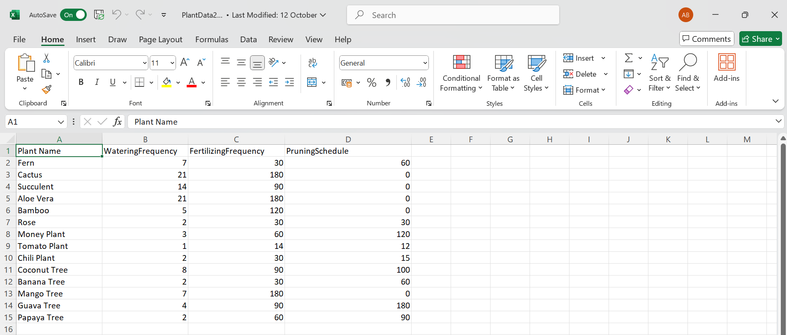

**Fig 5.5 Plant Data in Excel Sheet**

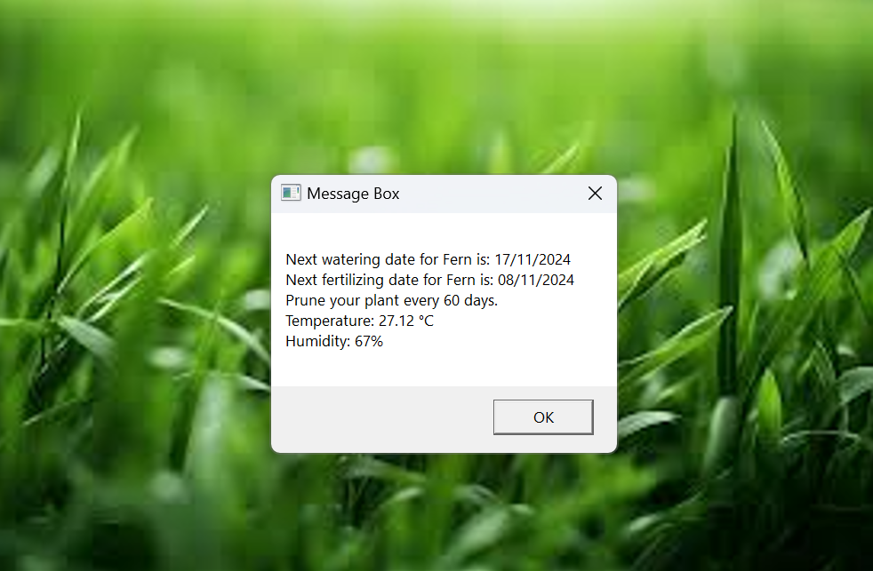The above Figure Shows the Excel sheet with all input data, including plant types, last watered and fertilized dates, growth observations, and location

## **Fig. 5.6. Output Display of calculated dates**

The above Figure Displays the output generated by the bot, including calculated watering, fertilizing, and pruning schedules for each plant based on the input data.

**CHAPTER-6**

**CONCLUSIONS**

The ***Green Care Assistant Bot*** has proven to be an effective and efficient solution for managing plant care. By automating key tasks such as scheduling watering, fertilizing, and pruning based on both plant-specific data and real-time weather conditions, the bot significantly reduces the manual effort required to maintain healthy plants. Its integration with Excel for data management and a weather API for localized care suggestions ensures personalized and up-to-date recommendations, improving the overall quality of plant care.

The automation not only minimizes human error but also allows users to focus on other important aspects of plant management by providing clear, actionable recommendations. In conclusion, the Green Care Assistant Bot stands as a valuable tool for both amateur and professional plant care, helping ensure plant health through timely, data-driven care routines, ultimately making plant management simpler, more effective, and more efficient.

**6.1 GENERAL:**

In general, Automation is transforming everyday tasks by improving efficiency, reducing human errors, and offering personalized solutions. Projects like the **Green Care Assistant Bot** highlight how technology can simplify routine responsibilities, such as plant care, by integrating real-time data and user inputs to deliver accurate and timely recommendations. By leveraging tools like UiPath and APIs, this project demonstrates the potential of automation in enhancing the quality of life while saving time and effort. Such innovations pave the way for smarter, more sustainable solutions in various domains, including agriculture, horticulture, and personal plant management, ensuring a balance between technology and nature.

**APPENDICES**

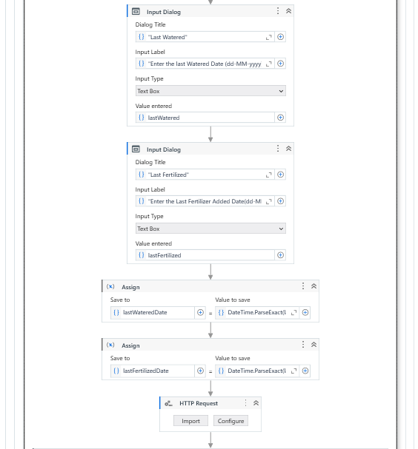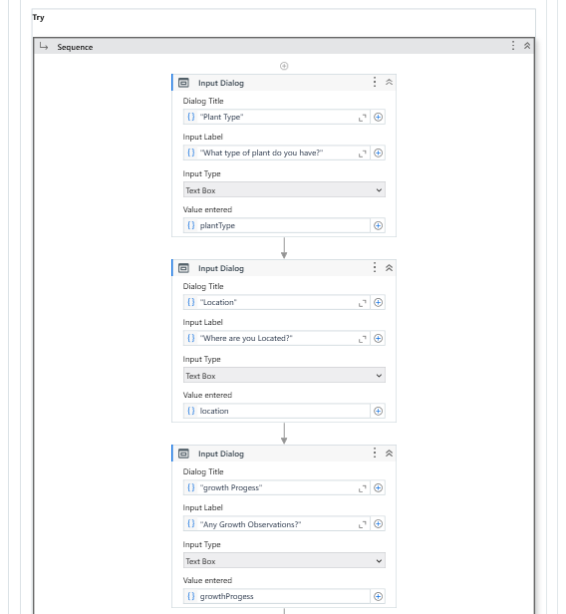**PROCESS WORKFLOW**

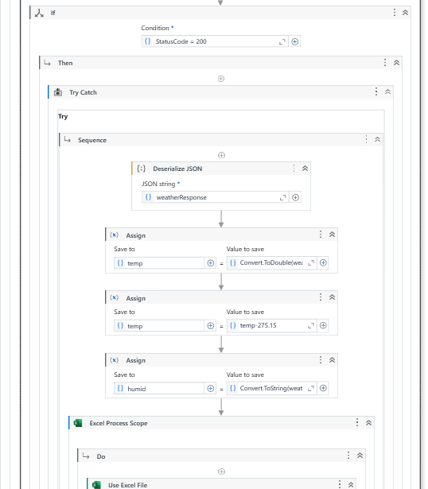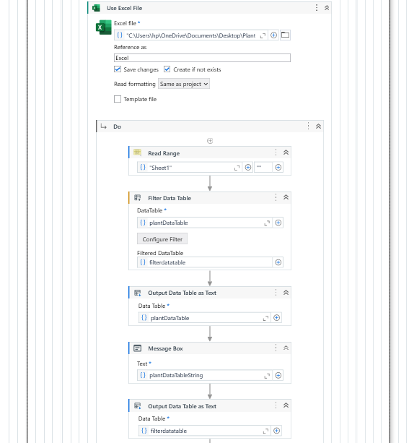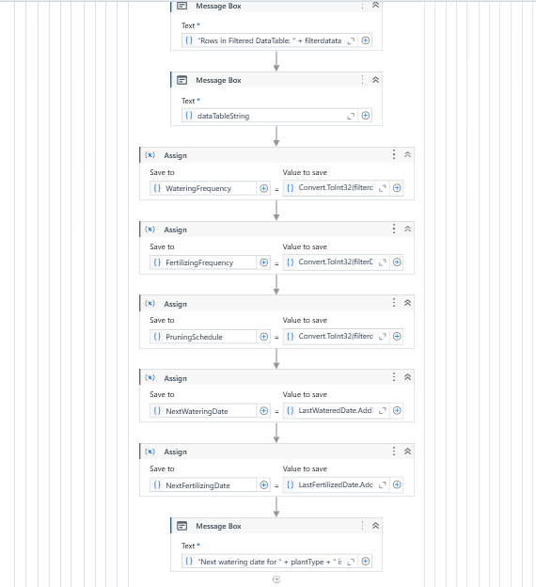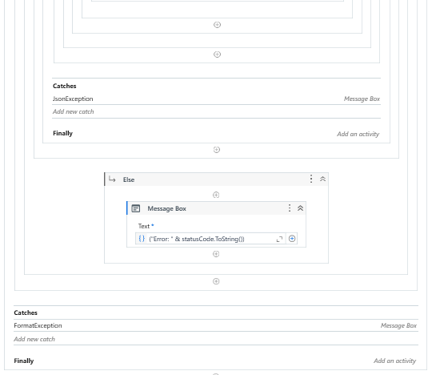

**REFERENCES**

* [***A Smart Cable-Driven Parallel Robot Assistant for Individual Plant Care in Farming***](https://ieeexplore.ieee.org/document/9752311/) ***-*** <https://ieeexplore.ieee.org/xpl/conhome/10488912/proceeding>
* ***Revitalizing Traditional Health practices with Healing Hands: An AI Powered Chatbot-*** <https://ieeexplore.ieee.org/xpl/conhome/10488912/proceeding>
* ***Design and Implementation of an Autonomous Plantation Layout Follower Fertilizer Bot for Advanced Farming-***<https://ieeexplore.ieee.org/xpl/conhome/10488912/proceeding>
* [***MedPlantBot: AI Chatbot Architectural Design Framework for Responsible Use of Medicinal Plants***](https://ieeexplore.ieee.org/document/10456018/)**-**https://ieeexplore.ieee.org/document/10456018/
* [***Plant Care: Community-Driven Agri-Aid***](https://ieeexplore.ieee.org/document/10489523/) ***-***https://ieeexplore.ieee.org/xpl/conhome/10488912/proceeding